
 | Coral Reef Cleanup Activity

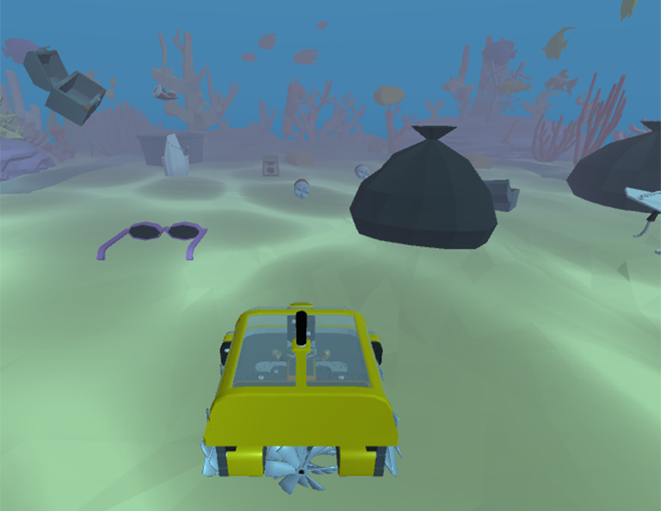

Code your VR Ocean Cleaning Robot to collect as much trash as possible from the Mangrove Reef before the battery runs out!

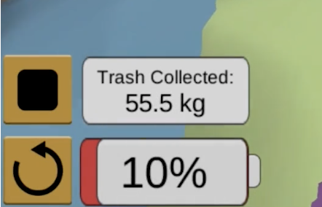
Key Information:
- The VR Robot is equipped with a solar charger and a battery.
- The battery's charge only lasts a few minutes — collect as much trash as possible before it drains completely.
  - Remaining battery life, along with the total trash collected in kilograms, is shown at the bottom-left of the Playground.
- The VR Robot has sensors that monitor its location and detect trash.
- The VR Robot must not collide with the coral reef. If it does, the mission will immediately end.
Using VEXcode VR
Navigate to vr.vex.com to launch VEXcode VR.
 | The Start button will start your project. |  | The Stop button will stop your project. |  | The Reset button will reset the Playground.
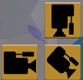  Use the Camera buttons to change the camera view and see the reef from a different perspective. |  |  |   Use the Open Playground button in the Toolbar to open the Playground Window.

Reminders & VEXcode VR Tips
- Balance speed with battery life – Driving faster drains the battery on the robot more quickly.

- Try waiting – More trash falls to the floor the longer your robot is running.

- Use a sensor – The VR Ocean Cleaning Robot is equipped with multiple sensors to detect trash and the blue border around the coral reef.
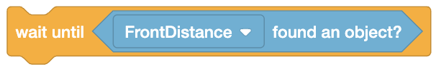
  - Try using a Wait until block with a sensor to make the robot drive until the Eye Sensor detects trash.

- Look for help – More information about the Playground and the blocks available to use with the VR Ocean Cleaning Robot is available at api.vex.com.

Coral Reef Cleanup
Activity Notes

Hands-on time for this activity is approximately 30-45 minutes.

Facilitating the Activity
- Introduce the activity. Share the video linked below to introduce students to the challenge.
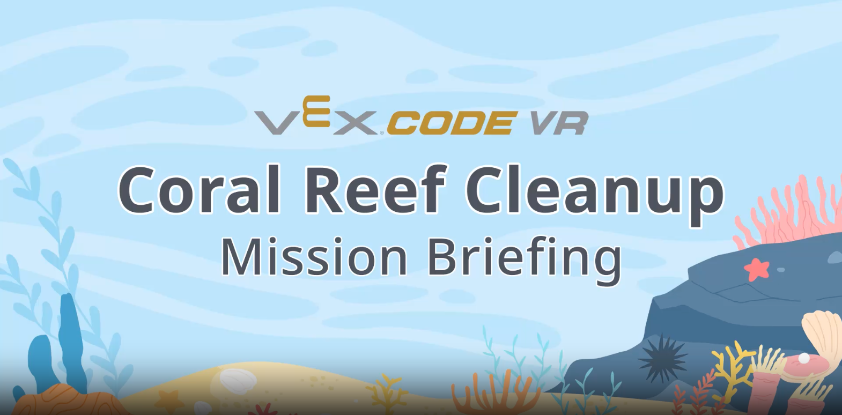 | Use this link to show a video to the whole group and get students excited about coding their VR Ocean Cleaning Robots to clean the Mangrove Reef!
- Open and run an example project with students.
  - Launch VEXcode VR and choose the Coral Reef Cleanup Playground.
  - Open the Coral Reef Cleanup Level 1 example project. For more information on how to open an example project, see this article.
  - Have students run the project.
- Add on to the example project with students. Look together at where the robot ends when the example project is complete, and brainstorm how the robot should move to collect the next piece of trash in front of the robot.
  - When the project is stopped, a splash screen will appear, as shown to the right. Select the X in the upper-left corner to close the splash screen and see the ending position of the robot.
  - Show students how to drag a drive for block into the workspace and attach it to the bottom of the stack, as shown here. Set the distance parameter to 800 mm to collect the next piece of trash.
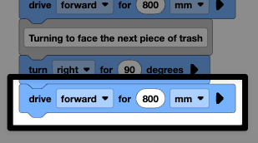
  - Select the Reset button in the lower-left corner of the Playground Window to reset the Playground.
  - Start the project again. Watch the robot collect both pieces of trash.
- Have students keep building on the project to collect trash. Circle the room and facilitate by asking questions and/or sharing strategies to help students complete the activity.
  - Questions to ask:
    - How much trash has your robot collected?
    - How did you code your VR Ocean Cleaning Robot to move around the reef?
    - Did your plan work the first time? If not, what did you do differently the second time?
  - Strategies to share:
    - Trash will continue to fall as time passes, accumulating more quickly the longer you wait. Students may want to add a wait block to their projects to allow more trash to accumulate before they start driving.
    - The robot’s battery drains faster at higher velocities. Encourage students to consider this, and how the trash falls, as they are developing their strategy for the challenge.

Extending the Activity
- Have students incorporate sensor data into their projects. The VR Ocean Cleaning Robot is equipped with Distance, Eye, and Bumper Sensors that can detect trash objects, the blue line around the Playground floor, and more.
  - Students can use the Level 2 example project to see one way the Distance Sensor can be used to detect trash.
  - Students can use the Level 3 example project to see an algorithm that uses the Down Eye Sensor to avoid the blue line on the Playground.

